Dear Friends of RSAMCC:

During these uncertain times, our organization has decided to keep moving forward as we have families and community organizations that need our support. We believe when life hands you lemons, make lemonade. The Redstone Arsenal Military and Civilians’ Club (RSAMCC) will once again host our annual fundraiser “Gala in the Garden.” We continue to strive to serve our military service members, their families and our local community through volunteer service as well as providing community assistance grants and educational scholarships for qualified military and civilian dependents. Sponsorship support last year was phenomenal! We were able to provide merit scholarships and community grants in the amount of $33,600. RSAMCC would like to form partnerships with sponsor organizations to not only meet this goal, but to exceed it! We ask for your generosity in achieving this goal.

The Huntsville Botanical Garden is a perfect and beautiful setting for our annual fundraising event:

“Gala in the Garden”
October 22, 2021
6:00 – 9:00 pm
Huntsville Botanical Garden
Grand Ball Room

This is our primary source of funding for the aforementioned grants and scholarships. We would like to invite you to attend and/or Sponsor “Gala in the Garden” by providing a monetary donation in support of this event.

Below are the details concerning this year’s sponsorship levels:

- $5,000 – Camellia Level: Reserved Corporate table with 8 event tickets, your company name on a digital sign at the event, company logo on event programs, reserved table, recognition in the RSAMCC monthly newsletter and invitation and recognition to attend our annual Merit Scholarship Awards ceremony.

- $2500 – Crepe Myrtle level: 4 event tickets, your company name on a digital sign at the event, company logo on event programs, recognition in the RSAMCC monthly newsletter and invitation and recognition to attend our annual Merit Scholarship Awards ceremony.

- $1,000 – Magnolia Level: Two event tickets, your company name on a digital sign at the event, logo on event programs, recognition in the RSAMCC monthly newsletter, invitation and recognition to attend our annual Merit Scholarship Awards ceremony.

- $500 – Hydrangea Level: Company logo on event programs, your company name on a digital sign at the event and recognition in the RSAMCC monthly newsletter.

- $250 – Daisy Level: Logo on event program and recognition in the RSAMCC monthly newsletter.

I appreciate your time and consideration and ask for a contribution / a partnership to make this our best annual fundraiser to date! I would love to discuss this with you if you have any questions or would like additional information, please feel free to contact me, or Stacey Harring at rsamccfundraising@GMAIL.COM. Thank you for your consideration and support. I look forward to hearing from you!
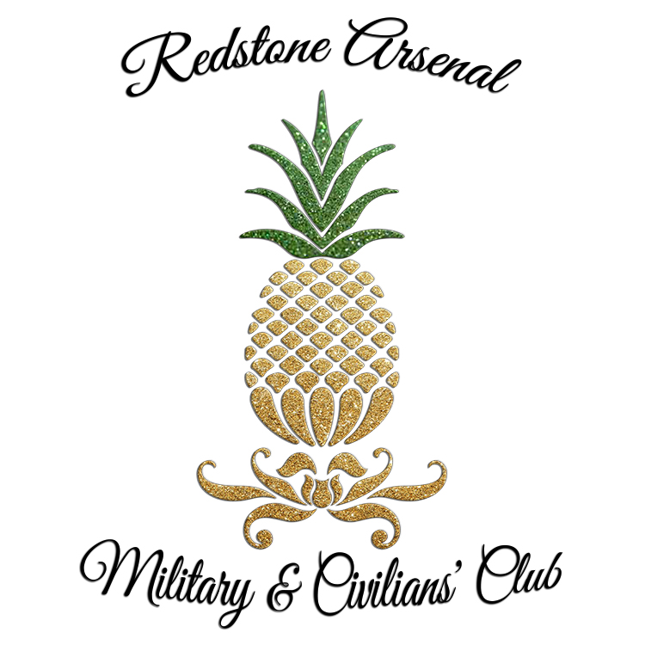

Sincerely,
Cherie L. Cain
RSAMCC Fundraiser Chair
rsamccfundraising@gmail.com
254-368-5363

